WikiWalks

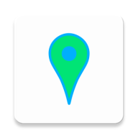

**User Manual**

Created by Joey Lunt, Sanjay Dass, and Tyler O’Neill

# Introduction

This document serves as a user guide for WikiWalks, a beta application developed for Android that allows users to find and record bush walks in their area. It aims to provide a simplistic and easy to use alternative to similar applications like Wikiloc, which is functional but bloated and complicated with unnecessary features that can make it confusing to use. WikiWalks strips this down to what is needed. Paths with different routes, points of interest, reviews, photos, and scheduling group walks. This document will go over each of these features, how to use them, and how to test them.

# Main Screen

This is the first screen you will see upon opening the app. The app will check your location, and display satellite imagery of your area using Google Maps. It will then make a request to the WikiWalks server to download the paths within the map bounds. As you move the map around, it will continue requesting paths. If you zoom out so that more than 3 degrees of latitude or longitude are shown, the request will not be sent for performance reasons. A screenshot can be seen to the right. In this screenshot you can see 2 paths, marked by the lines and markers. The colour of the lines will change depending on how popular the path is. From this screen there are a few options – clicking a marker will bring you to an information page about the path, clicking create new path will allow you to record a new path. The gear in the top right will take you to the settings page, and the bookmarks icon will take you to a list of paths you’ve bookmarked.

## Testing

Not much needs to be tested here. Open the app, grant the location permission, and wait a few seconds. If the map moves to your location, and if you do not see a toast pop up notifying you that it failed to get paths, the test has succeeded. This is ideally done in an area where you know there are paths so you can see the test succeed by paths appearing on the map.

# Paths

Paths are the base of all content on the app. Each path can have a number of different routes and points of interest. The path menu, displayed from clicking a marker on the map, is shown below. On the left, the initial display. On the right, the full menu accessible from scrolling.

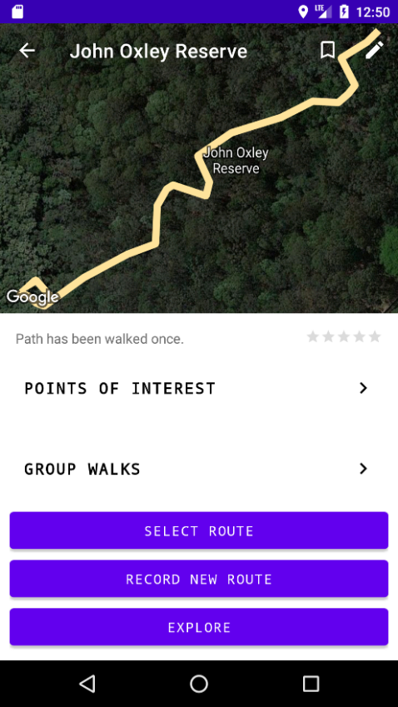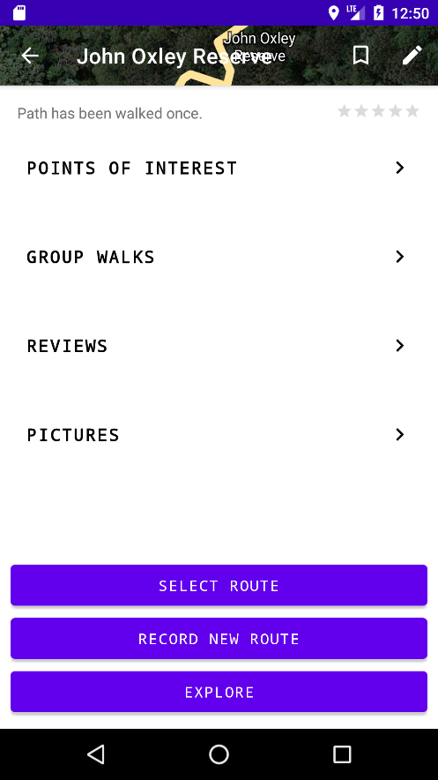

This screen displays the path name in the toolbar, how many times it’s been walked, and its average rating (in this case there are no reviews so it is blank). There are also a number of buttons. Starting from the toolbar, the bookmark icon will toggle whether the path is bookmarked. The pencil icon will bring up a dialog that allows users to edit the path’s title. Next, in the scroll menu, buttons will take you to points of interest, group walks, reviews, and photos. These will be covered later. Finally, there are the 3 buttons at the bottom.

The select route button will take you to a menu showing colour-coded routes on the path and their distance. You can select a route to walk, and if you created the route, you also have the option to delete it. Selecting a route to walk will take you to a new screen with the route overlaid. Pressing the explore button on the main path menu will do the same but display all routes overlaid. When off the route, an indicator will be shown with the distance and direction to the nearest point. This UI contains buttons that allow users to mark points of interest at their current location, and to upload photos. The route list and walking UI are shown below.

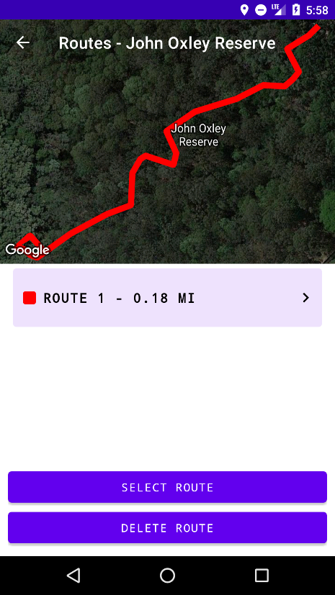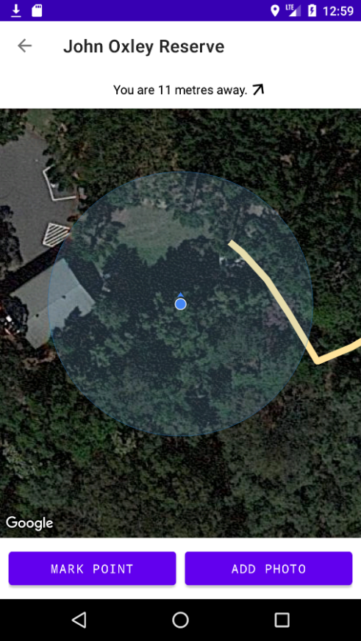

Finally, there is the record new route button. This, along with the create path button on the main screen, will take you to a screen that will record your movements and display them as a white line. Once the stop recording button is pressed, if this screen was initiated by the new route button, it will add a new route to an existing path. Otherwise, it will prompt the user to enter a path name and create a new path with the route. If you choose not to submit, you may resume recording, however you will not be allowed to if you are too far away from where you stopped. The screen also contains a button to mark a point of interest, which will be submitted with the route. Below is an image of the recording UI on the left, and an image of the name popup on the right.

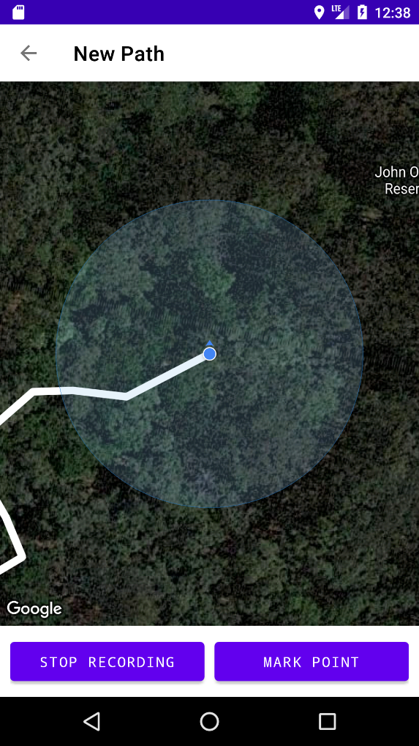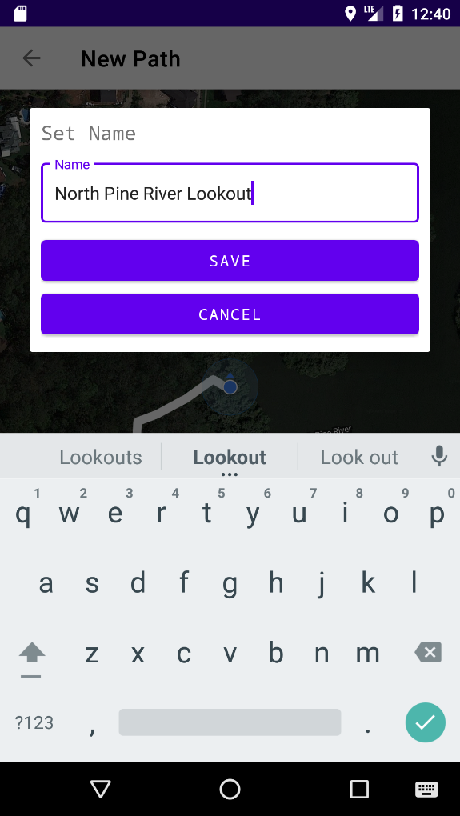

## Testing

Testing path functionality requires a few steps. First, click the create path button. Walk around until a decent sized path has been created. Mark a point of interest while walking. Stop recording, enter a name, and submit it. The path should then appear on the map. Click on the path’s marker, and ensure the path menu loads successfully. Click on the points of interest button to ensure that the point of interest you marked is there. Go back to the main menu and press the record new route button. Walk another path and submit it. Go back to the path menu and ensure that there are now 2 routes in the select route menu. Select one and ensure that it shows the route. Go back to the main path menu and click explore. Ensure that it shows both routes. Then, go back to the main path menu once again. Click the edit button, and enter a new name. Ensure it updates. Then, click the bookmark button. Go back to the main map screen, and click the bookmarks button. Ensure that the path is there. Go back to the main path menu, then into routes, and delete the routes. The path should then automatically disappear once all routes have been deleted.

# Points of Interest

Points of interest are notable points along a path that can be marked within the app. They can be submitted while recording or walking a path, and are accessible from the path menu and from the walking screen. The points of interest button on the path menu will bring up a list of points of interest, with colour coded markers, and clicking one of these or a marker on the walking screen will bring up its menu. The point of interest menu is very similar to the paths menu and will allow users to upload photos of and review points. Any user can also rename the point using the pencil button on the toolbar, and the user who created the point may delete it with the trash icon. Below, the points of interest list and point of interest menu can be seen.

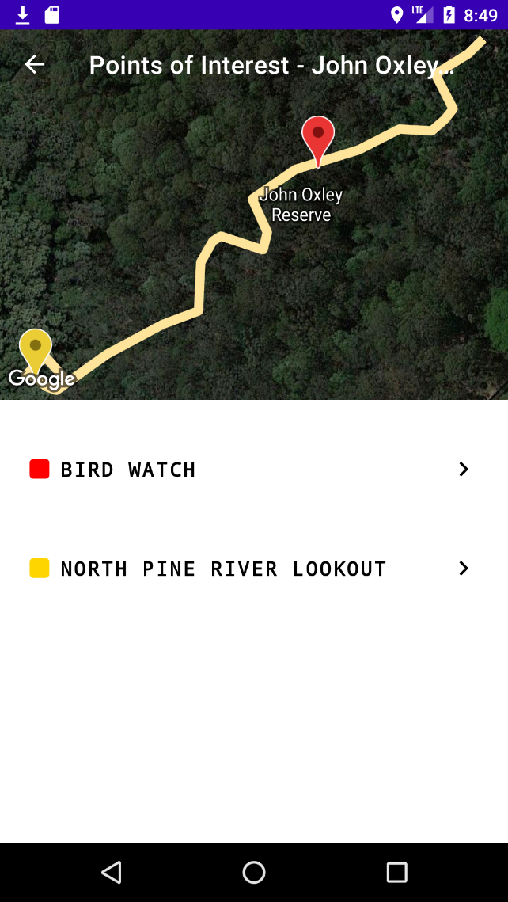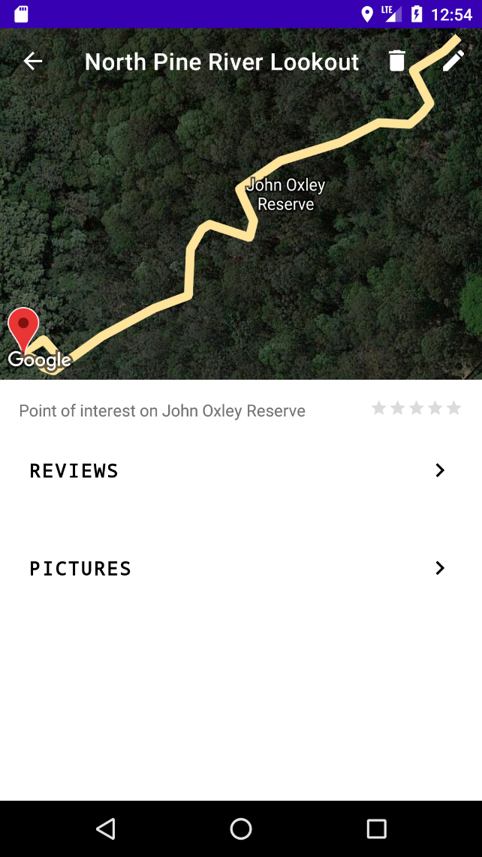

## Testing

Testing point of interest functionality is simple. First, open a path from the menu and choose to walk a route. Once on the walking screen, click the “mark point” button. Enter a name and return to the menu. Once there, check that it is in the point of interest list. Click on the point you marked, then click the edit button, and change the name. Ensure it updates. Then press the delete button and confirm that you want to delete it. The menu should then automatically close and take you back to the points menu with that point gone.

# Reviews

Reviews can be written for both paths and points of interest. Both the path menu and point of interest menu have a reviews button, both of which will take you to the same interface and allow you to see reviews for them or write your own. The reviews menu will show your review separated at the top, and other reviews in a list below them, loaded 10 at a time, from most recent to oldest. At the bottom of the screen will be a button to either write a review if you don’t already have one, or edit your review if you do. These will bring up the same menu, with a delete button visible if editing, allowing you to submit or edit your review. The save button will not be enabled until you select a star rating. The reviews menu and edit dialog are shown below.

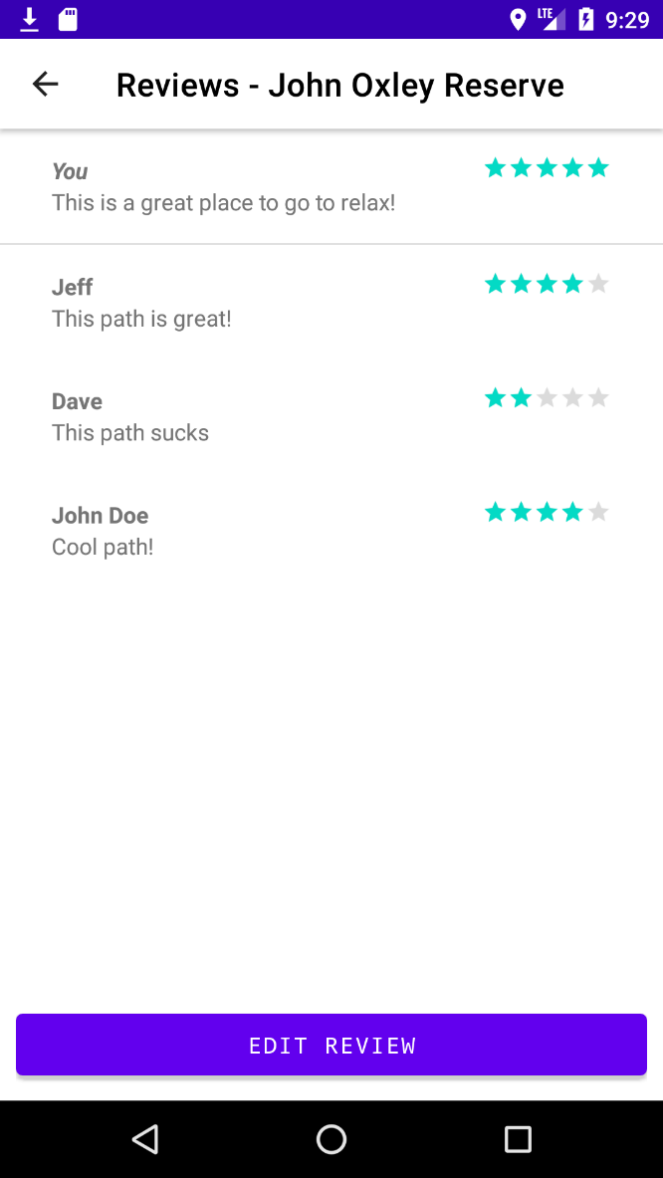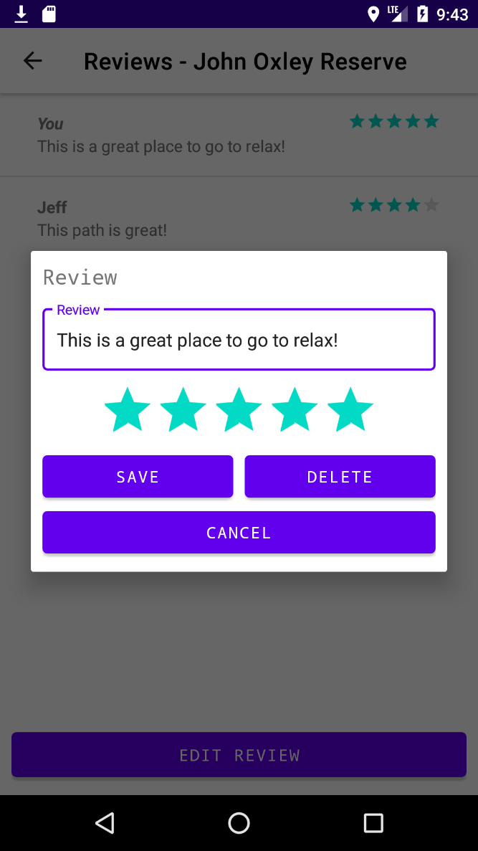

## Testing

Testing the reviews functionality is quick and simple. First, find a path and open the path menu. Click on the reviews button. You should see either reviews for the path, or a message saying no reviews can be found. Next, click the write review button. Choose a star rating and optionally enter a message. Hit the save button and make sure the review appears at the top of the screen. Next, click the edit review button where the write review button was. Change your message and your star rating. Hit save, and ensure it updates. Finally, hit the edit review button again and click delete. Hit yes on the prompt that asks you to confirm, and ensure the review disappears.

# Photos

Similarly to reviews, users can submit photos for both paths and points of interest. This can be done mid-walk using the add photo button on the walking screen, or from a separate photos menu that can be accessed from the path and point of interest menu. This will bring up a popup that has the options to choose a photo from either the gallery or camera, and caption the photo. These photos are displayed in a list, loaded 10 at a time, from most recent to oldest showing the user who submitted it and a caption. The user who submitted a photo can also edit the caption or delete the photo using the pencil icon. If there are no photos for a path or point of interest, a notification will be shown. Below are images of the photos menu and the submission dialog.

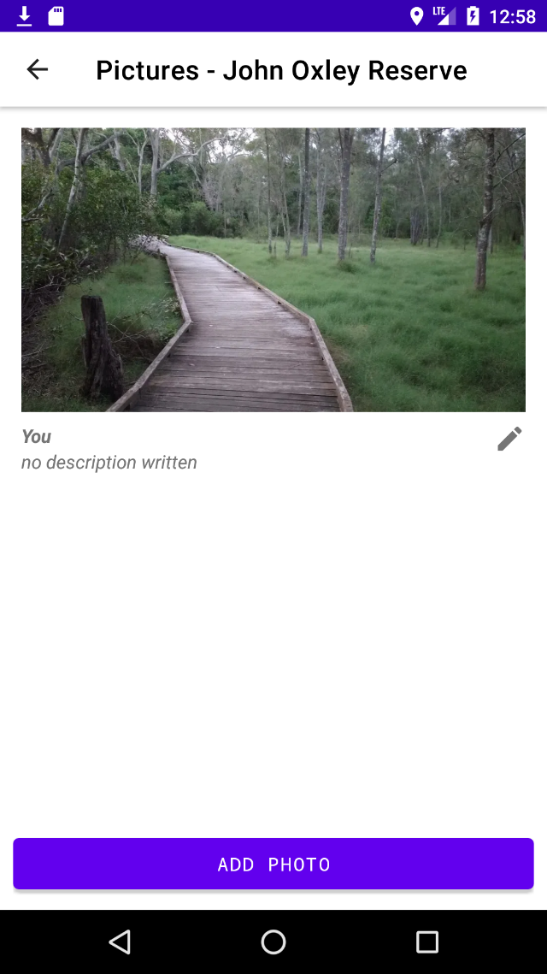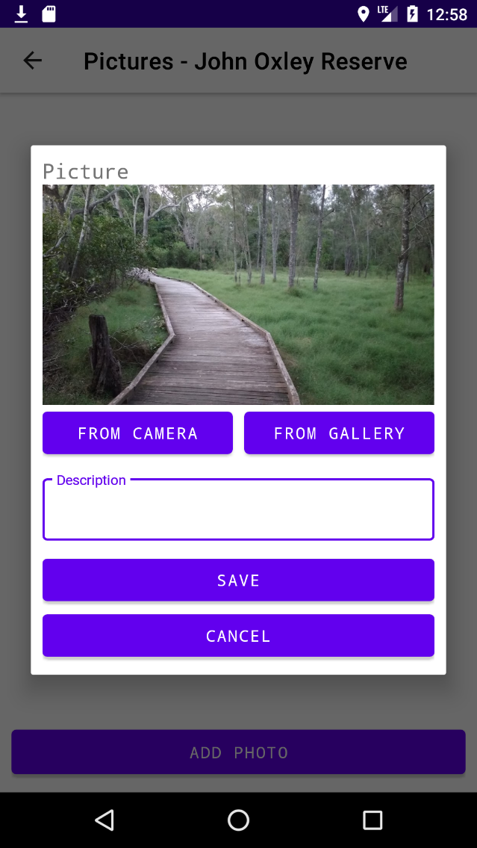

## Testing

There are a few steps in testing photos functionality. First, select a path and choose a route to walk. Hit the add photo button and choose to take a photo from the camera. Once a photo has been selected, write a description and hit save. A toast should appear notifying you that the photo has been submitted successfully. Next, go back to the path menu and open the photos menu. You should see the photo you selected. Hit the add photo button, and choose a photo from the gallery this time. Write another caption and hit save. The photo should appear at the top of the list. Then, hit the pencil icon next to one of your photos and change the caption. Ensure that it updates when you save it. Finally, hit the pencil icon and hit delete. Confirm that you want to delete it with the prompt, and ensure it disappears. Repeat this with the other photo.

# Group Walks

Group walks are walks scheduled at a path at a specific time through the app. It allows creation and marking attendance. This can be done through a menu accessible from the paths menu. When accessed, the app will display a list of future scheduled walks with their time, host, and attendees, and show a button allowing creation. Next to each listing will be a checkbox for marking yourself as attending. Users who created a group walk will not see the checkbox, but instead a pencil icon that allows for changing details or deleting the walk. Below are images of the group walk menu, creation dialog, and calendar that appears when pressing the select time button.

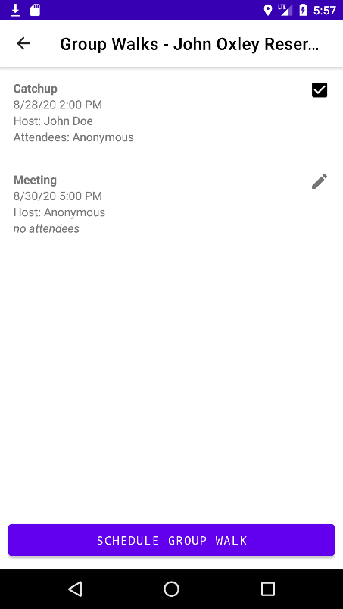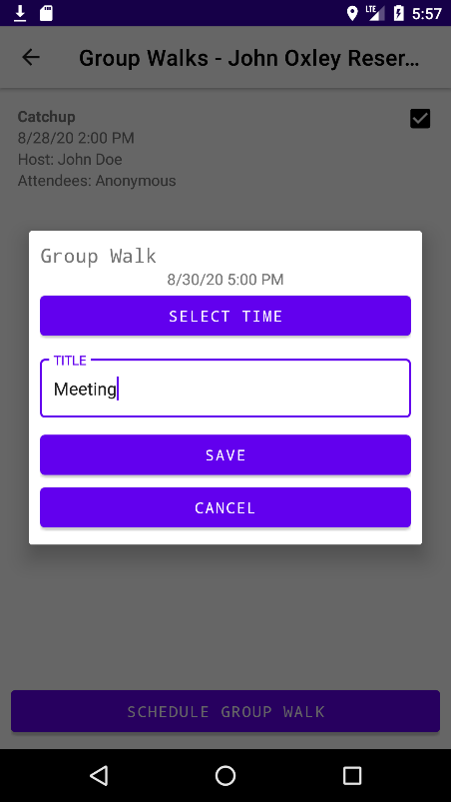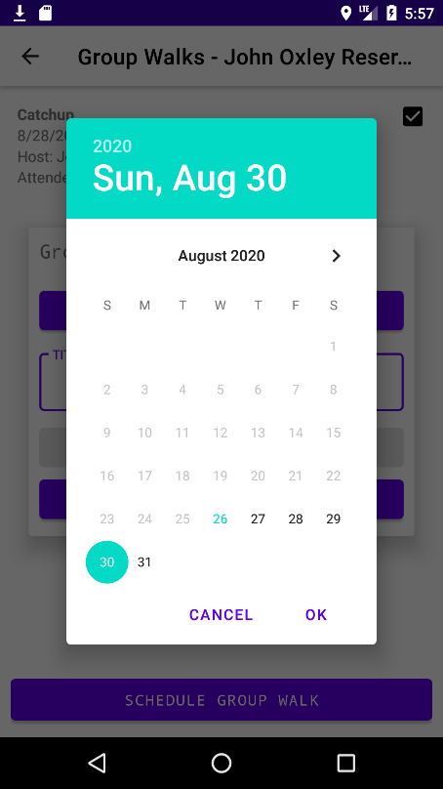

## Testing

Testing group walks is a little difficult as you will either have to find another group walk to test attendance on, or clear the app data after creating one so it no longer registers you as the creator. First, open a path menu and click on the group walks button to take you to the group walks menu. Click the schedule group walk button. Choose select time, and use the calendar and clock popups to enter the time. The time should appear as you chose it above the button. Optionally, enter a title, then hit save. You should see the group walk listed. Hit the edit button and change the title. Ensure the title updates in the list. Then, hit the edit button once again and press the delete button that should now appear. Confirm you want to delete it, and ensure it disappears from the list. Next, create another group walk and either access it from another device or clear the app data so that accessing it shows a checkbox instead of a pencil. Press the checkbox and ensure your name (by default Anonymous) is now in the attendees section. Then press it again to remove yourself and ensure you are no longer in the attendees.

# Settings

The settings menu is accessible through the cog in the toolbar on the main screen. The app’s settings are very simplistic, in fact there is only one real setting – your name, which appears on reviews, images, and group walks you submit. The settings menu also allows you to access statistics and goals, and to import and export your data, which includes a unique device ID for editing submissions and bookmarks. Below are images of the settings menu and the popup for setting your name.

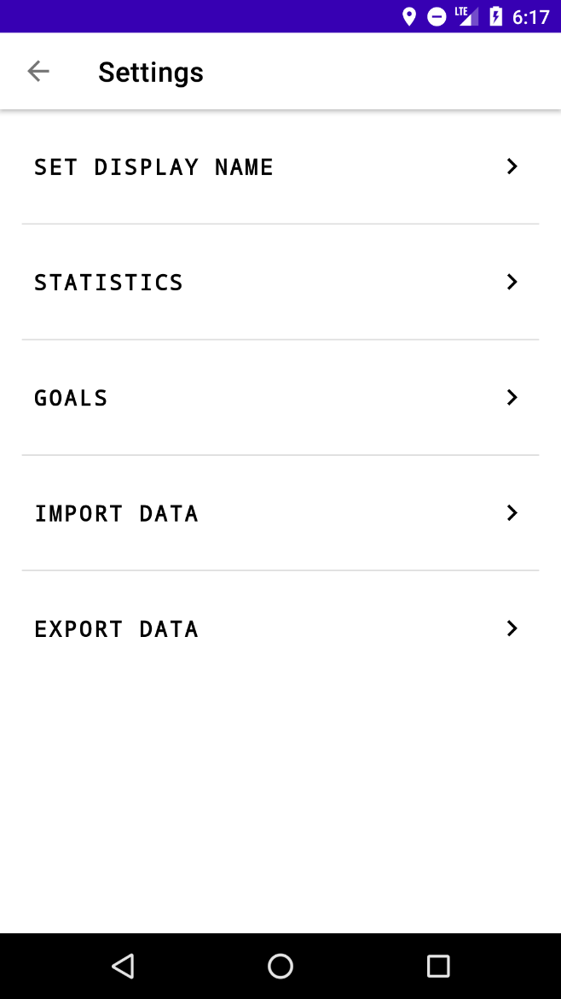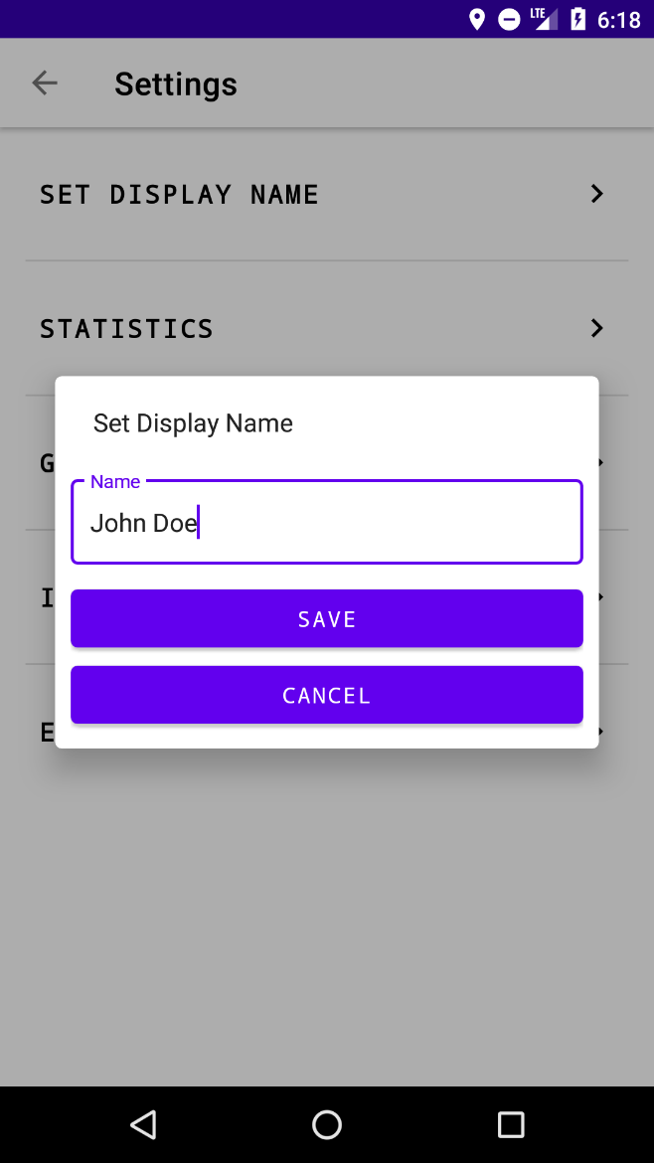

Next are statistics and goals. Statistics does exactly what you’d expect – bring up a list of user statistics. These are all stored locally and can be imported/exported. Statistics tracked includes distance walked, number of times walked, routes recorded, reviews written, and photos uploaded, along with a few others. Goals allow the user to set a distance and a date they’d like to walk it by and are displayed in a list, with a green highlight when completed or a red highlight when failed. Below, from left to right, are the statistics page, the goals page, and the goal creation popup.

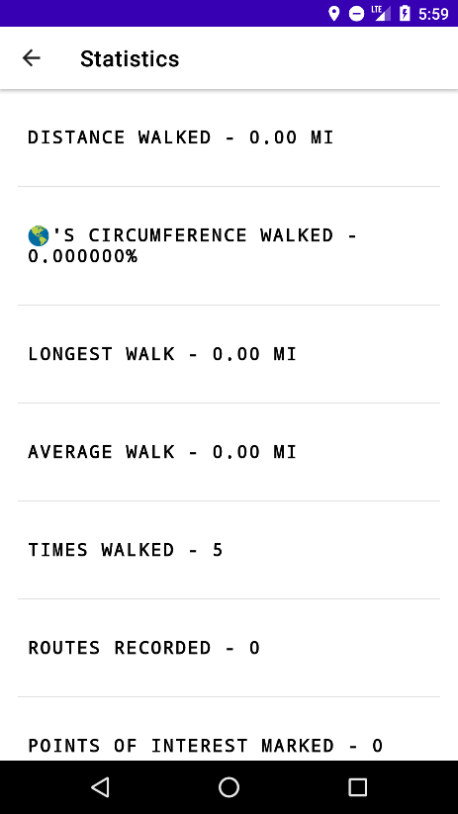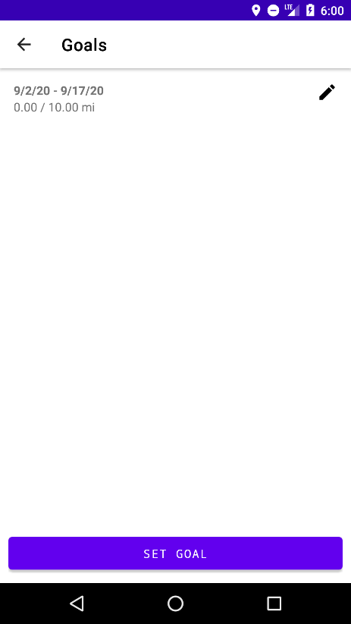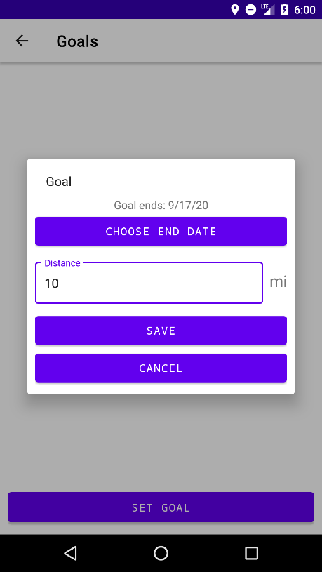

Importing and exporting data is a very simple process. Pressing the export data button will bring up the system’s file browser that allows you to choose your directory and filename. Once you choose, it will save a JSON file to that location. Pressing the import data button will bring up a very similar UI that will allow you to navigate and find a backup. If you select a file that is not a backup, it will not break anything and will just continue as if you did not import anything at all. Below are images of the export UI (left), and import UI (right). The appearances may vary across Android versions and manufacturers, but the functionality will be the same.

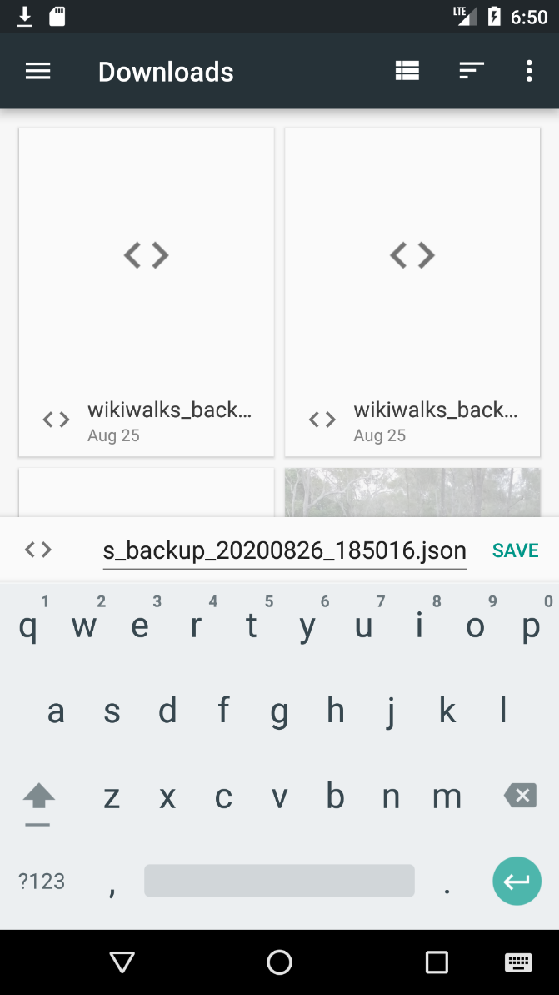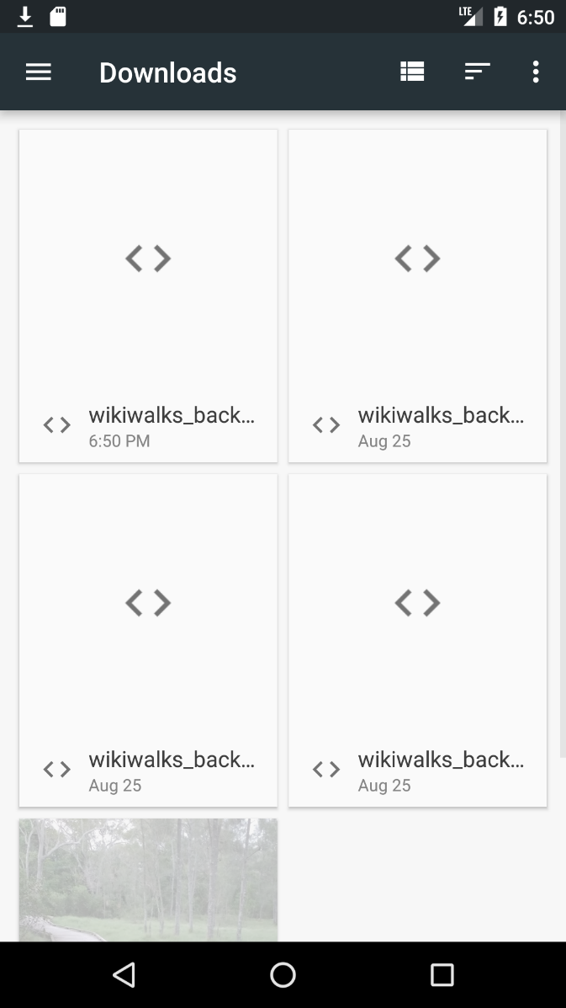

## Testing

To test setting your name, simply click the set name button and enter a new name. Hit save and it will display a toast if it was successful.

To test importing and exporting settings, first bookmark a path. Then hit the export settings button and save the backup to a location of your choice. Next, clear the app’s data. When reopening the app, the path should no longer appear in bookmarks. Go back to the settings menu and press import settings. Choose the backup you just made. Return to bookmarks, and ensure that the path you bookmarked is back there.

# Troubleshooting

There are no known bugs in the current version. The majority of problems will be caused by internet access and GPS reception. If paths are failing to load or submit, ensure your internet connection is stable and not blocking the WikiWalks server for whatever reason. If the app is detecting your location poorly, this is due to GPS reception. The app utilises Android’s APIs for getting the location, and unfortunately there’s not much that can be done to resolve this. Otherwise, contact the developers with a description of your problem and we will work to resolve it.